Confirmation Page
- If you need a confirmation page after you have sent an item, locate the item you sent in the Web Portal. (How to find a sent item)
- Open the item and scroll to the bottom of the page, select the Print Item Details button.
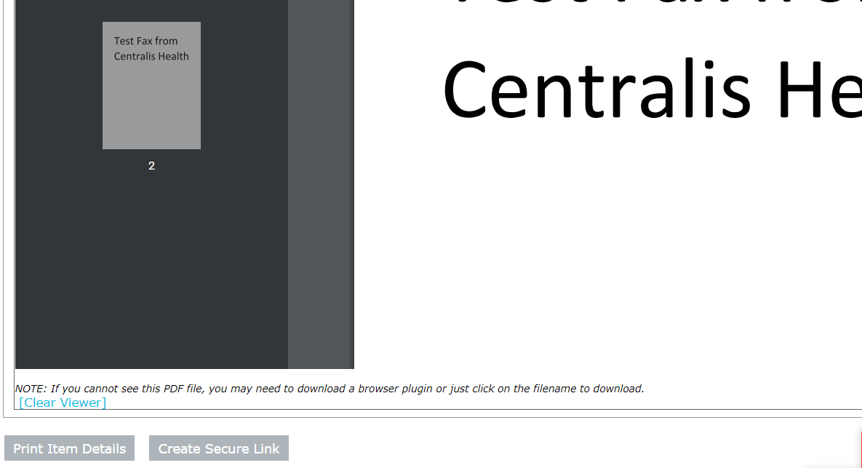

- This will open your confirmation page. This page can be printed, but we encourage you to save it as a PDF and import directly to patient chart. 